

**EAST WEST UNIVERSITY**

**Fall-2020**

Course Code: CSE411

Course Title: Software Engineering and Information System Design

Section: 02

**SRS Report-1**

**Project: IT System and Service Management**

**Name of Web Application: “Proxima”**

**Submitted To:**  
Md Mohsin Uddin

Senior Lecturer

Department of Computer Science and Engineering

**Submitted By:**

Tashfia Choudhury (2018-1-60-045)

Sanjeda Sara Jennifer (2018-1-60-061)

Shafiul Mahmud Partho (2018-1-60-219)

Date of Submission: 28/11/2020

**TABLE OF CONTENTS**

**Topic Page**

**Introduction & Motivations** 3

**Challenges**  4

**Component Diagram** 5

**Requirements** 5 - 10

Non-functional Requirements 5 - 6

Functional Requirements 6 – 10

**UML Usecase Diagram** …………………………………………………………...………..11-15

**UML Class Diagram** …………………………………….………………….....………………16

**UML Activity and Sequence Diagrams** 17- 19

UML Activity Diagram for Scenario #1 17

UML Activity Diagram for Scenario #2 18

UML Activity Diagram for Scenario #3 19

UML Sequence Diagram Scenario #1 20

UML Sequence Diagram Scenario #2 21

UML Sequence Diagram Scenario #3 22

**Entity Relationship Diagram** 23

**User Interface Screenshot** …………………………………………………………………

**Technologies** ……………………………………………………………………………….

**Conclusion** …………………………………………………………………………….........

**Introduction**

“Proxima” is a platform focusing on two main criteria - providing IT-related services to clients or customers and on skill development where one can enroll in the available courses to increase their knowledge and level up their skills. Firstly, people who are looking for a photo shopper, graphic designer, and video editor etc. have it all in one place. Secondly, students or anyone can join the courses offered and learn from our experienced instructors or, they can opt for the free version where the online resources are provided in an organized way to make learning easily accessible and available to everyone. This document contains the software requirements specification(SRS) for the website.

**Motivations**

* One of the main purposes of this website is to encourage and facilitate learning so that learning or developing a new skill becomes easier for everyone. Many students give up after going halfway through due to the lack of proper guidelines and resources and for not being able to utilize the available ones. The other part deals with providing the requirements of clients or customers such as, Photoshop, video editing, making logos, business cards, banners, etc.
* Our website is targeted to the people of all generations. Everyone wants to get services or make someone professional else to do their work. We are building this web application for them so that their time will not be wasted and they are getting services from professional workers so that the money they are investing is not worthless.
* This web application is mainly for the younger generation who want to start working but there’s not much that they can do to get a job or something. Therefore, in order to overcome that, we are offering them these courses completing which they will be able to start working and in the long run, this would also help them strengthen their career and make their CV much stronger compared to others in the work field.
* This is also a learning web application where any users of all ages can come and learn about various IT courses. The students who are willing to learn but can not find a proper guideline, this is a place for them. We are making the learning process easier for them. Also, many students will not be able to pay for the courses, but they do not need to worry because we are giving proper resources (links) for courses so that they can learn on their own.
* Proxima aims to reduce the cost and hassle of the client by ensuring that they can get most of their software or IT related work from one place instead of going or approaching different places for different tasks. This saves time too.

**Challenges**

* Implementing certain features such as uploading files on the website.
* Since this project is entirely team-driven, we lack any client or upper-management feedback. Lacking well-defined client-requirements will make the development process a little more difficult.
* Due to the lack of client-defined deadlines, proper time management will also be an issue.
* Getting familiar with technologies we haven’t worked with before, for example, Django.
* Making sure the UI isn’t too technical or cluttered and follows the latest design trends.
* Responsiveness of the website.
* To ensure the website runs perfectly on any devices/platforms such as smartphones, smart-televisions, any browser, etc.
* Ensuring strict client security and protecting the client’s data.
* Enhancing security with python and MySQL.
* Sending a confirmation email to the person who is trying to open an account or register to ensure that he/she has provided a correct and valid email address.

**Component Diagram**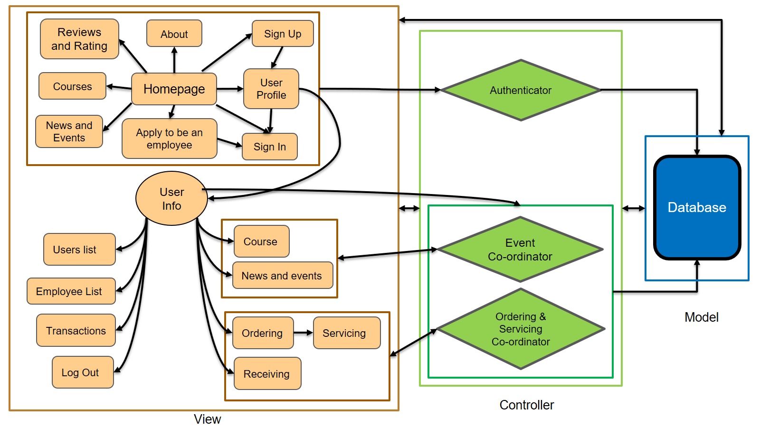

**Requirements**

**Non-Functional Requirements**

* This web application has to be easy to use for all kinds of users as every detail will be written in easy English that helps to understand easily. The design of this web application is not very congested and easy to find the desired field. An easy to use and the intuitive user interface is to be developed with this goal in mind.
* Our web application has to be search and time-efficient so that the users can run and see their output as quickly as possible. The performance of this web application has to be optimized for all kinds of users and browsers.
* We have to ensure the ethical issues such as copyright issues and raw data selling between the users and the admin also the password encryption is an important part of our web application so that the hacker is not able to hack any of our users or admin data.
* We have to ensure excellent user experience (UX) by implementing a clean, intuitive, responsive UI.
* Our web application has to support the file uploading/downloading to implement most of its primary functions. Also, the login and logout system will be there.
* Our web application should have the ability to run in a computer browser as well as a mobile browser. In short, our web application has to be responsive so that it can be used anywhere by smartphone and computer. The goal is to ensure the highest level of compatibility by making the application platform-independent so that it is easily accessible to all.
* As we mentioned, our web application has to be time-efficient. It will not consume more electricity so that our environment will face fewer damages.
* We have to thoroughly ensure the user’s data and privacy is protected. Since our users will entrust us with their data, the highest priority should be given to protect such sensitive information. Also, there will be many files and transaction data that also need to be protected.
* We are using python and MySQL database for our web application and building high security out of it and making it available for every user.
* This website must have options for a customer to get the following services:

1. Photos and video editing,
2. Logo designing,
3. Business card,
4. Banner design,
5. App development,
6. Software development.

* This website must offer the following courses for the students:

1. Introduction to Java
2. Introduction to Python
3. Introduction to Bootstrap
4. Adobe Photoshop and Illustrator
5. Video Editing

**Functional Requirements**

**Homepage:** The homepage of our website is available for all the viewers. On the page, the content about our web application will be shown. The viewers can learn about our web application and they can see the upcoming events and news of it. There will be many buttons such as “About”, “User Profile” “Sign Up”, “Sign In”, “Review and Ratings”, “News and events”, “Courses” “Apply to be an employee” etc.

**User authentication:** Since our web application deals with sensitive information about the user’s file, data, transactions a thorough authentication procedure should be followed. Our team aims to use authentication to streamline the user login and registration process and ensure industry-level quality.

**Scenario 1 (Sign Up):** When an outside user visits our homepage it will be fine but when he/she wants to see the “User profile” and press it then it will redirect him/her to the “Sign up or Sign In” page. After that, he/she has to create an account or register by using “Sign Up”. Then it redirects to their user profile**.**

**There will be 3 types of users: i. Admin, ii. User as Client or Student and iii. User as an Employee.**

**Admin:** Administrators of the system. He/She does not have to sign up but sign in or log in.

**Input:** username, password

**Output**: user authentication,admin panel, access to administrative functions, logout, and all other sites.

**User as a client or student:** General end-users of our system; the targeted audience. This user can order IT services or apply for courses. These users have to sign up(register) when they first come to this webpage and want to create an account.

**Input:** username, password, confirm password, email id.

**Output:** user authentication, access to user homepage & profile, access to courses site and ordering site, and logout.

**User as an employee: The service provider of our system**. This user can give IT services or teach some particular courses. These users do not have to sign up (register) when they come to this webpage. They can just simply sign in to our system. When a user wants to be an employee, he/she can simply apply to be an employee. After that, if the application will be accepted by the admin or authority, then an account and password will be created for the employee and sent it to his/her email. Then he/she can use the password for logging in.

**Input:** username, password.

**Output:** employee authentication, access to employee homepage & profile, access to courses site and servicing site, and logout.

**Scenario 2 (Sign In):** When a regular user visits our homepage, he/she can go to their account by just logging in (Sign In). The user can have access to their specific authenticated site and do their desired job. They have to just click the “Sign In” button then it will give the option of inputting username and password. After doing that, he/she will have to press “Log In”. Then it will redirect to their specific profile.

**User profile:** In our web application there can be 3 types of user profiles. Each type of profile has different types of functionalities.

**Admin profile:** A user profile must have user details without the password, a user avatar, and other information about how he/she manages this web application. Admin profiles have some buttons that he/she can click and manage his/her desired section such as course section, news and events section, employee section, transaction section, user section, etc.

**Scenario:**

**Course Section:** When a user clicks the ‘Course Section’ it will allow the admin to see all the changes that the user makes. For example, the sections and time slots of the different courses that are offered (ensuring one doesn’t clash with another) that the user chooses will be visible to the admin. When all the seats are filled up, the admin will close the section so that no one else can register for that section.

**News and Event Section:** By clicking this section, the admin can see and manage the going on or upcoming events on this web application. An admin has the privilege to insert an upcoming event and delete it when the event is over. The update will be shown to all users in the News and Event section.

**Employee Section:** The employee section has all the information about the employees. When someone applies for the job and submits their CV, the admin will create an employee ID with the information provided on the CV and set a default password that the employee will change later. However, the admin cannot see the password of any employee. When an employee changes their address or contact number, it will be visible to the admin and can delete their ID if or when necessary.

**Transaction Section:** By clicking this section, the admin can see all the transactions in terms of money and what is happening in our web application. Admin can see what is ordered and how much money is transacting, which courses have the best sales. Also, the admin can pay an employee in this section.

**User Section:** The admin can see the details about every user on this website. He/she can delete a user account if any unexpected phenomenon happens.

**Logout:** The admin can logout when he or she wants to leave the website.

**User Profile as a client:** This user profile must have a user name and every other detail without the password. A user profile has many buttons such as the order section, review and rating section, receiving section, and logout.

**Scenario:**

**Order Section:** In this section, there are many types of sites such as Photo editing, Graphic design, video editing, App development, Website development etc. The user can choose the service he/she wants to get then click on it. After that, there will be a list of employees in that particular sector with ratings. He or she can choose one of them to get service. The employee details will be shown to the user. Using this information he/she can contact the employee and get his/her work done.

**Receiving Section:** In this section, the user can see that any file or parcel has come yet or not. If any file comes, the user can receive it and pay money to this particular employee.

**User Profile as a Student:** After registering to the website, a student can look up to the courses that are offered and the things they are interested in learning. There are two options for the registered students as shown below-

**Scenario 1:** They can enroll in the paid version of the courses where they get to learn directly from the instructors, complete the courses, do assignments and projects and gain deeper knowledge, and have the skill of building projects on what they have learnt. Students must do the payment while enrolling for the course.

**Scenario 2:** They can choose to learn on their own with the free resources that are provided on the website. Once a person registers, they will automatically be able to access the sources, links for self-learning, and learn from there with the guideline.

**User as an employee:** After login as an employee, he/she can go to his/her user profile. This profile must have a username, user avatar, and every other detail given in the CV. This profile has many buttons such as the servicing section, course section.

**Scenario:**

**Servicing section**: By clicking this page, an employee gets to see the due work for him/her to finish with the deadline. An employee also gets to see which client gave the work to him and the client’s information. There will be an uploading space below every work detail. When an employee finishes his work, he can go to this section and upload the complete project or file in the specific work’s uploading space. Then the client can receive it.

**Course Section:** By clicking this section, an employee who is now playing a role as a teacher can enter a course he/she wants to teach. Then under the course, he can update many events like when the class will occur, the meeting link, and he/she can also provide free sources about the course for the students who will not be able to do our paid courses. Also, an employee can update the news and event section about the courses.

**UML Usecase Diagrams**

**Diagrams included:**

1. Account module
2. Admin module
3. Service module
4. Course module
5. User module

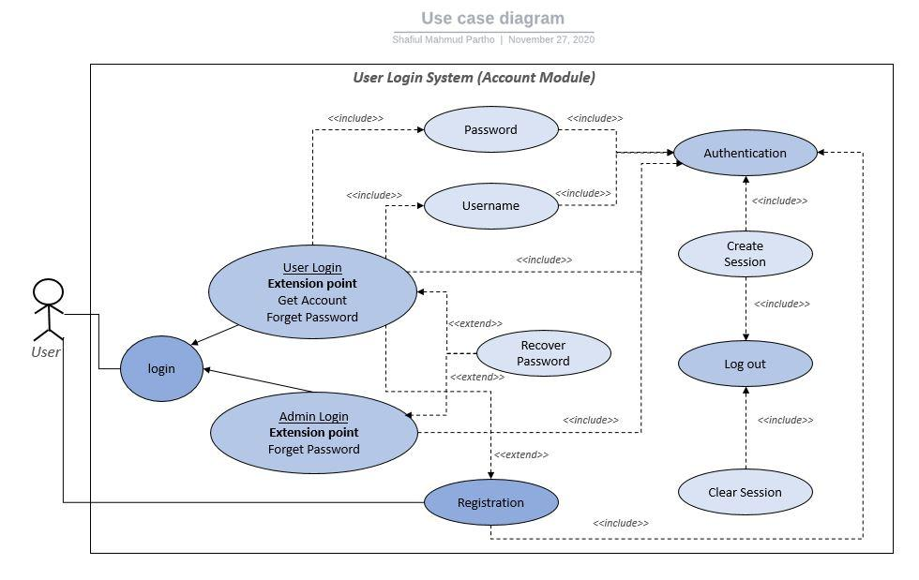

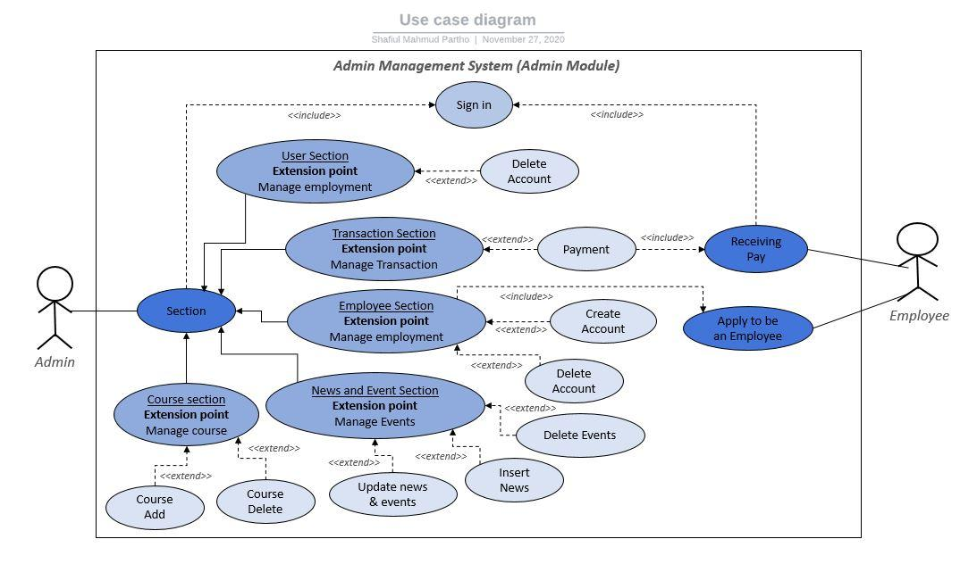

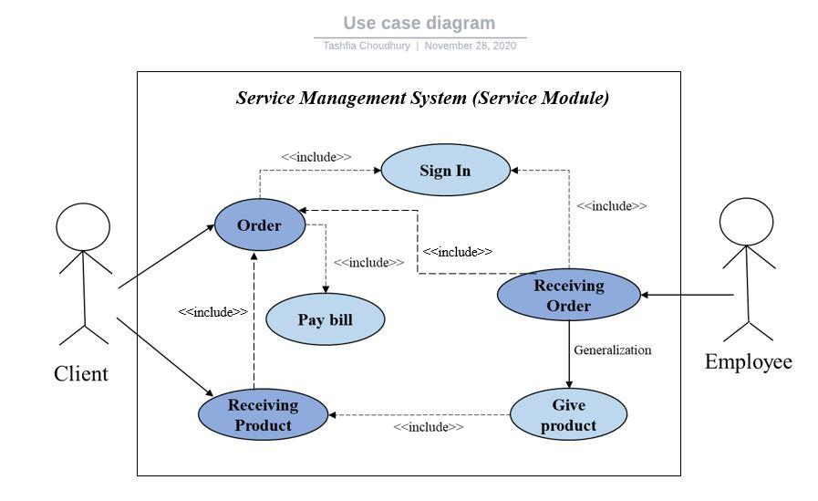

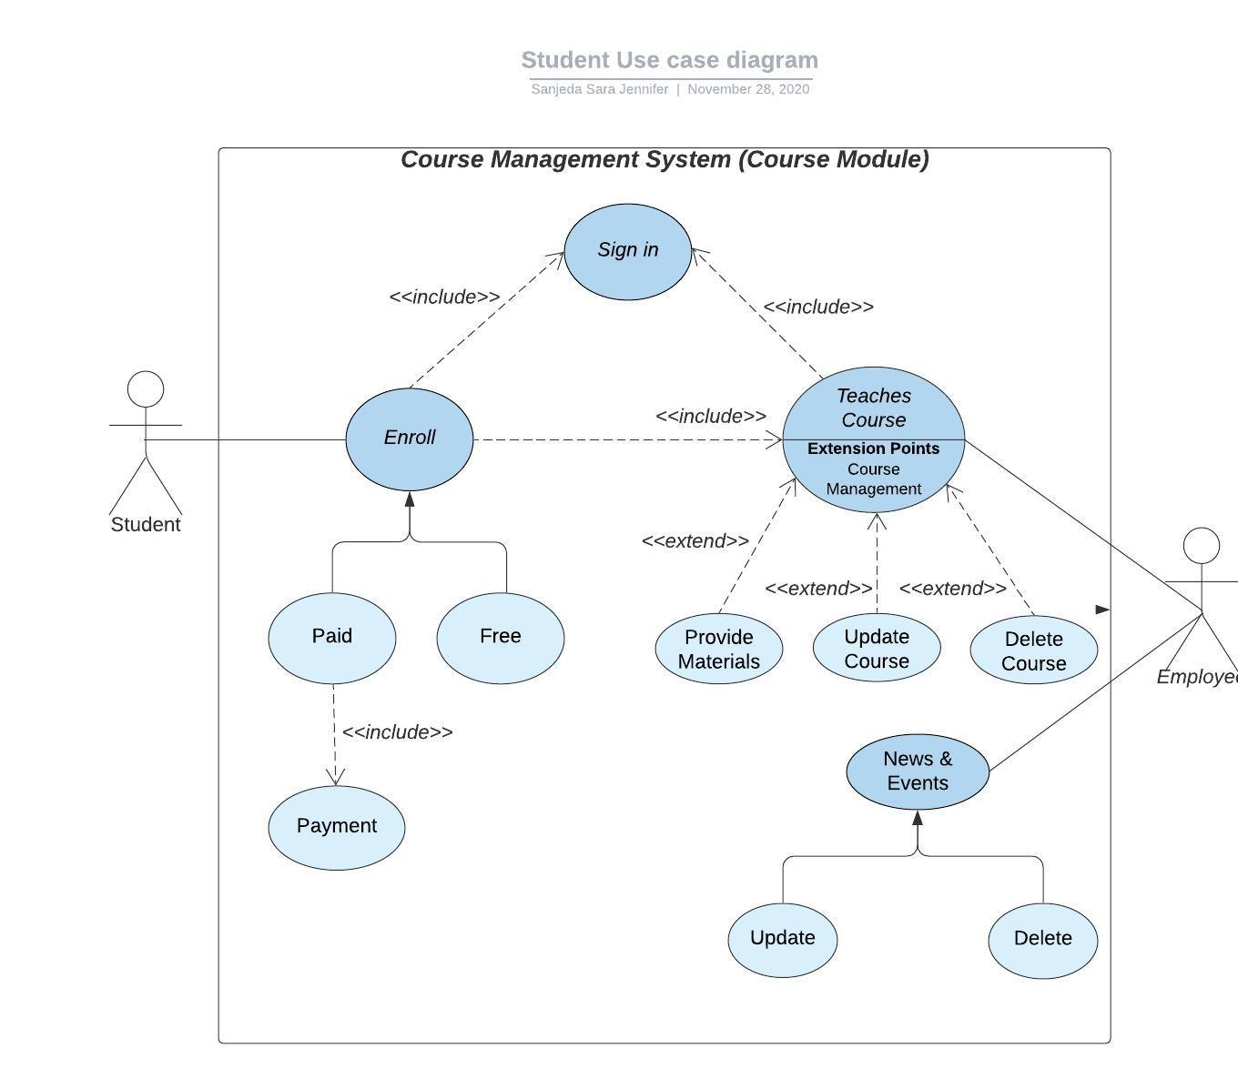

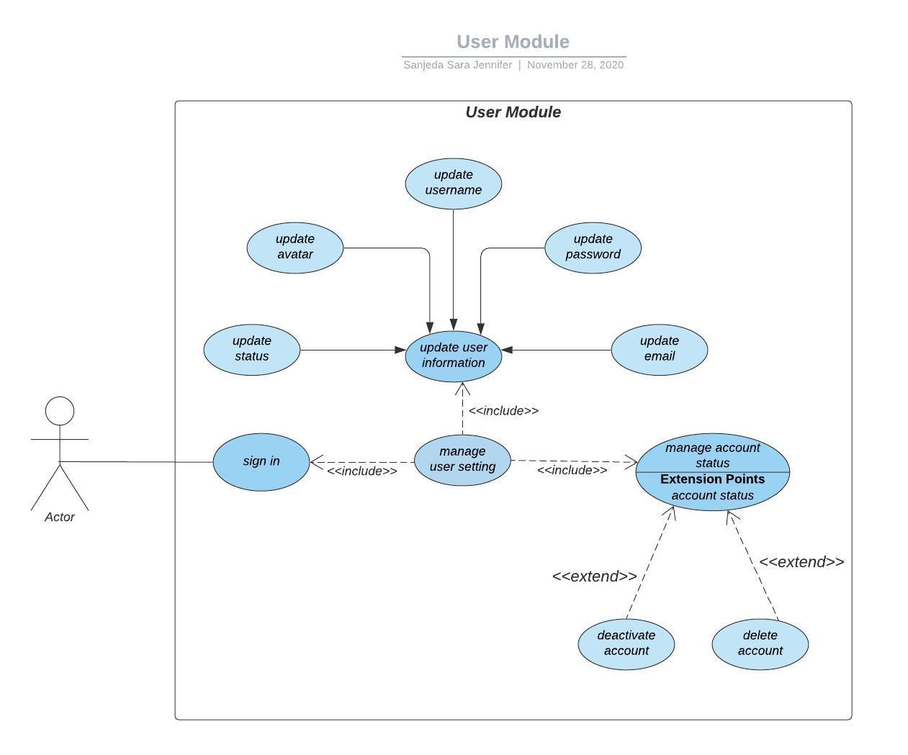

**UML CLASS DIAGRAM**

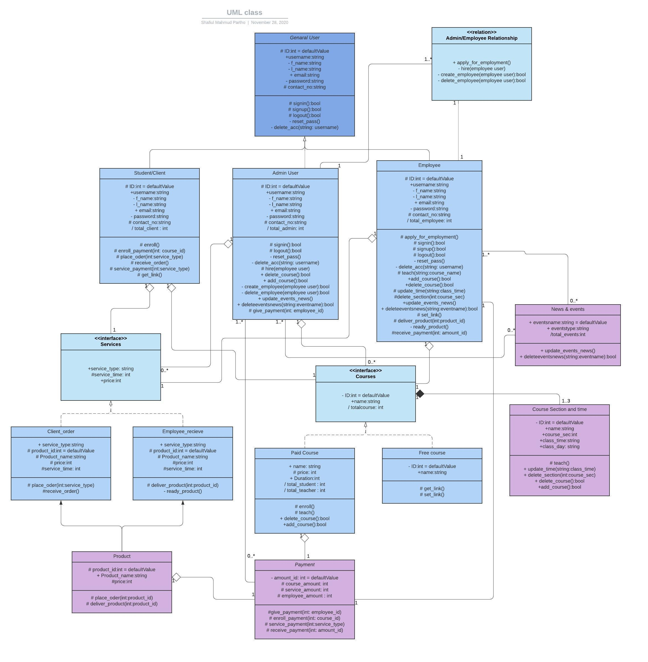

**UML Activity Diagram**

Scenario1: For placing order and enrolment in a course, when user visit our website, user needs to log in. For login, the user needs to input his password and the system will redirect him to the homepage once the login is authenticated and user can choose his desire option what he wants. If he wants to enroll in a course, he will get option for free course or paid course in the system, for paid course he needs to pay to the admin and then he will get enrolment and for free course he will directly get course related details. On the other hand, if a user wants to place an order, he needs to choose product type then an employee will accept the order and start to make the product. When the product will be ready employee will submit the work and the user will receive the product by giving the payment.

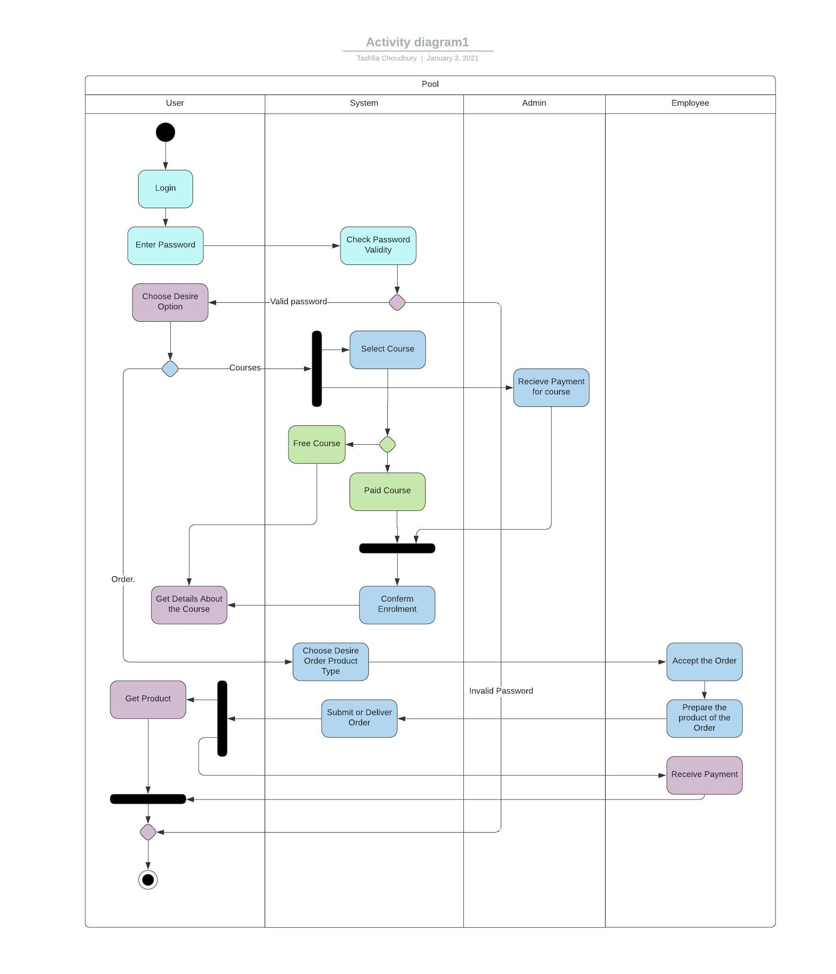

**Scenario2:** For becoming an employee, when user visit our website, user needs to log in. For login, the user needs to input his password and the system will redirect him to the homepage once the login is authenticated and user can choose the option for applying as employee then he will give details about him in the system from there the admin will check the details. If admin approve him as new employee, then admin will update employee information in the system as well as the user will get confirmation of employment or else, he will get rejection of employment.

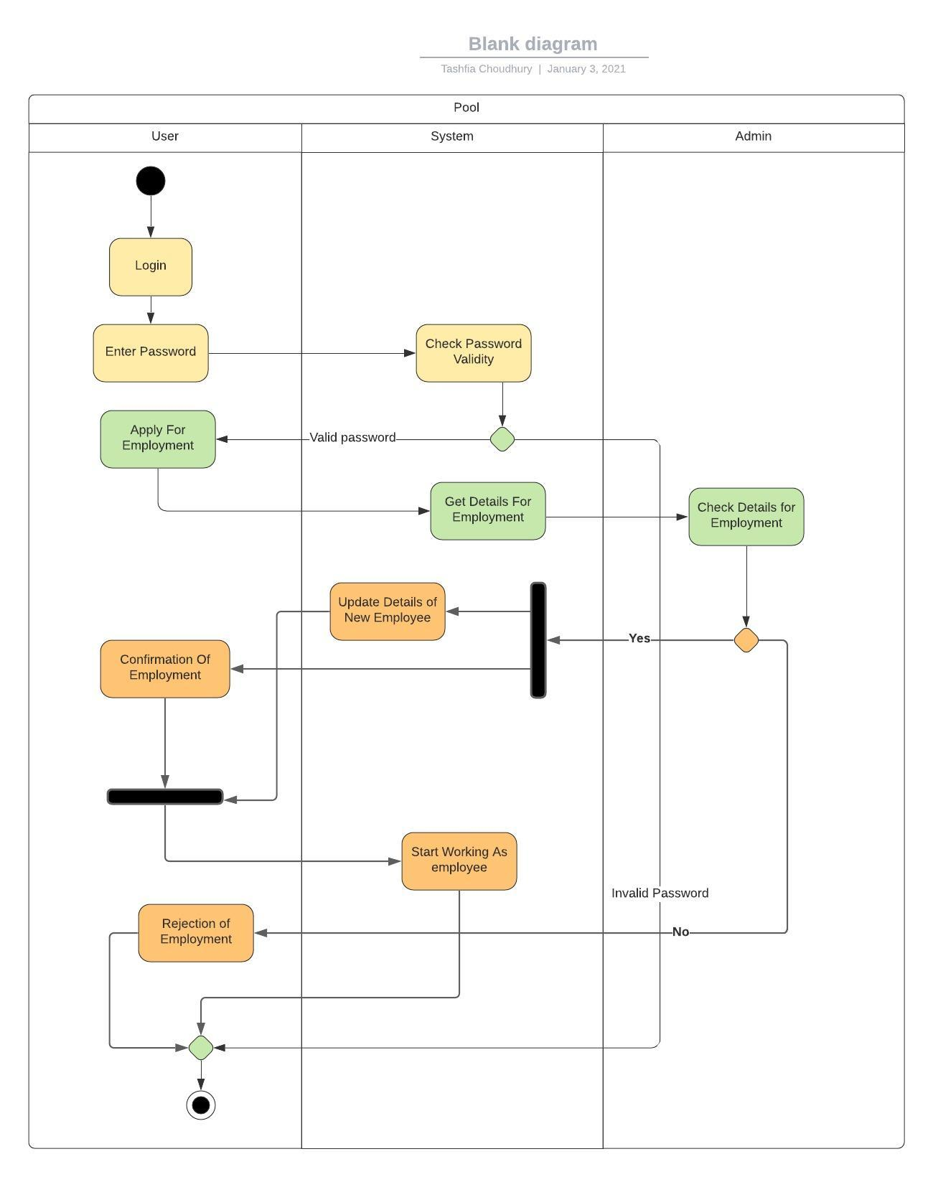

**Scenario3:** For checking other option like giving review & rating or edit profile or contact, when user visit our website, user needs to log in. For login, the user needs to input his password and the system will redirect him to the homepage once the login is authenticated and user can choose the option. For giving review and rating, the system will update it when the user gave review and ratings. For editing profile, the system will change it by the user’s wish. And for contact, the user needs to request for contact When the admin will accept the request, he will get information about how to contact.

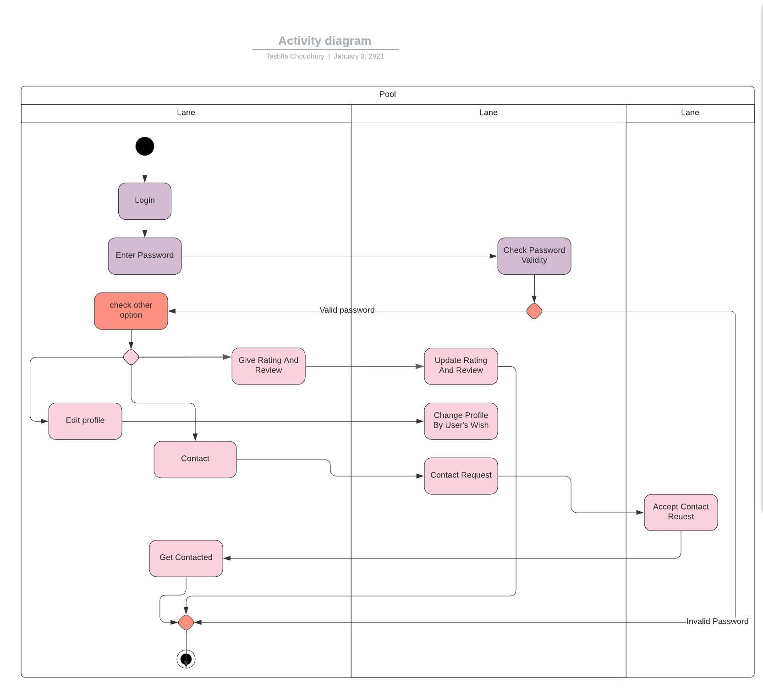

**UML SEQUENCE DIAGRAM**

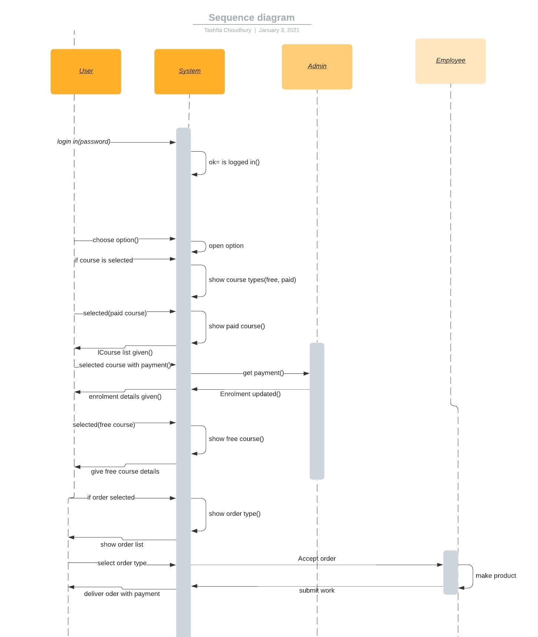

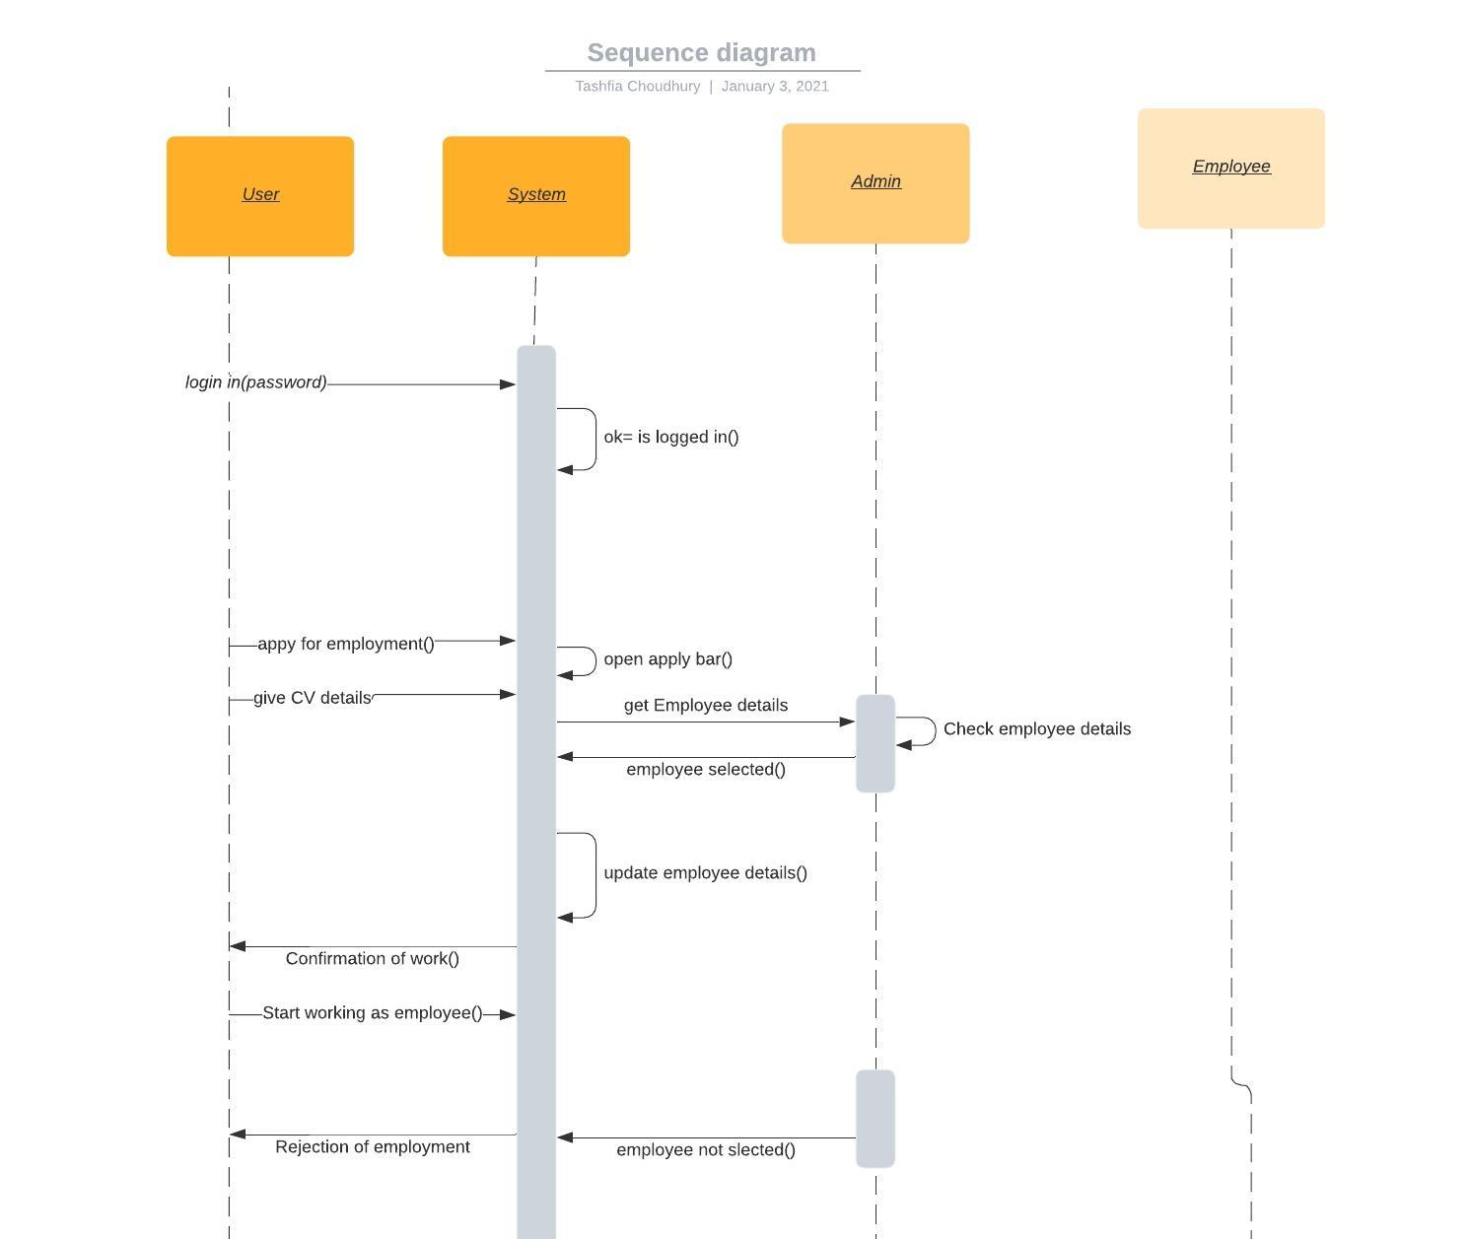

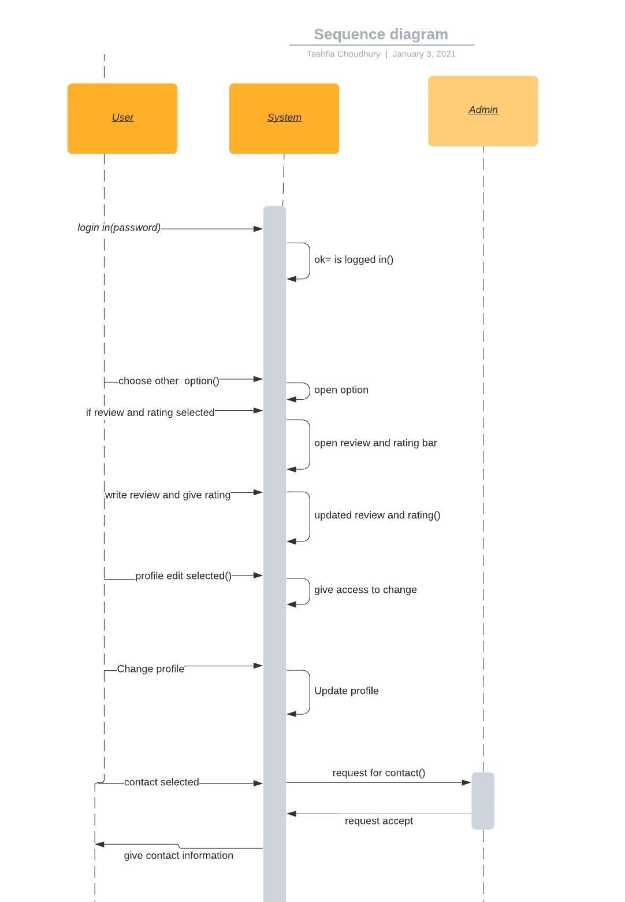

**ENTITY RELATIONSHIP DIAGRAM**

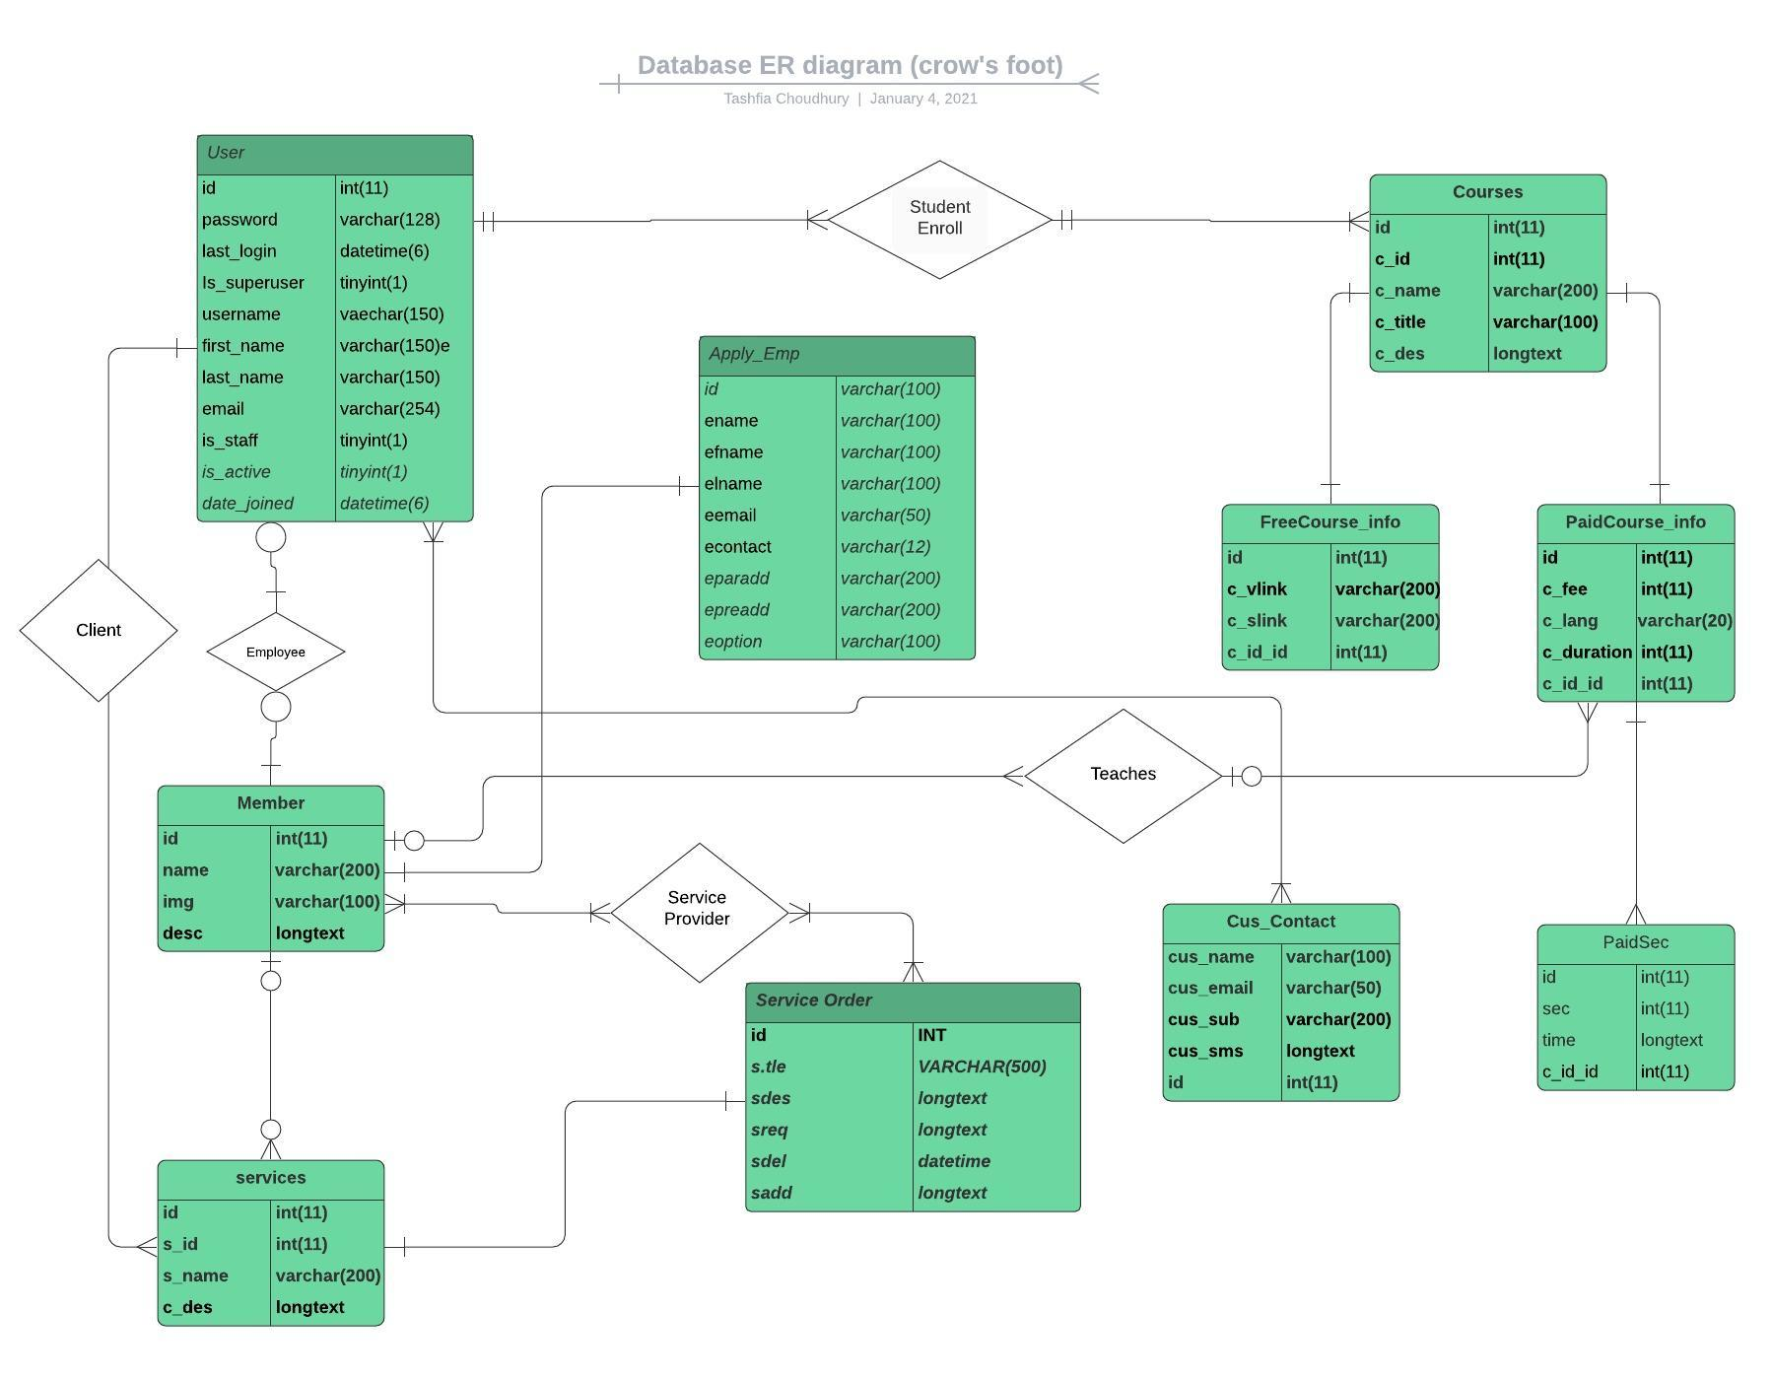

**Technologies**

We are using Python, HTML, CSS, Bootstrap, Django as language, and as the database, we are using MySQL in PhpMyadmin on the XAMPP control panel (Relational Database). Using this technology, we are hoping that we will be able to make higher security for our web application. We are also using an encryption method for user passwords.

**Conclusion**

This website would open many doors for the people all around since it is promising and providing not just one type of service, but multiple, and would be made efficient. This is a very basic and primary report of the software requirement specifications, and we would work toward our projects implementing all the points mentioned here and try to make it better by any means possible.